#### P527/1 PRINCIPLES AND

**PRACTICES OF AGRICULTURE**

**Paper 1**

**AUGUST. 2023**

2 hours

# Uganda Certificate of Lower Secondary Education PAPER 1 TERM II 2023

## PRINCIPLES AND PRACTICES OF AGRICULTURE

### S. 2 TIME: 2hours

**INSTRUCTIONS:**

* ***Answer all the questions in section A & one question in section B for sections A, write in the spaces provided and for section B write on the answer sheets.***
* ***Elaborate with clear examples where possible.***

**SECTION A**

1. Outline four methods of fertilizer application in cereal crop farming (4 marks)

…………………………………………………………………………………………………………

…………………………………………………………………………………………………………

…………………………………………………………………………………………………………

…………………………………………………………………………………………………………

…………………………………………………………………………………………………………

…………………………………………………………………………………………………………

1. State four ways of checking for moisture content in cereal grains. (4 marks)

…………………………………………………………………………………………………………

…………………………………………………………………………………………………………

…………………………………………………………………………………………………………

…………………………………………………………………………………………………………

…………………………………………………………………………………………………………

…………………………………………………………………………………………………………

1. As an upcoming agriculturalist, explain to the farmers two ways by which cereal growing is contributing to the national development. (2 marks)

………………………….………………………………………………………………………………

…………………………………………………………………………………………………………

…………………………………………………………………………………………………………

…………………………………………………………………………………………………………

2a). What is seed viability (2 mark)

………………………………………………………………………………………………………….…

……………………………………………………………………………………………………………

………………………………………………………………………………………………………

(b) State two methods of testing for seed viability. (3 mark)

………………………………………………………………………………………………………….…

……………………………………………………………………………………………………………

……………………………………………………………………………………………………………

………………………….…………………………………………………………………………………

c) Mention the various methods of breaking seed dormancy (5marks)

………………………………………………………………………………………………………….…

……………………………………………………………………………………………………………

……………………………………………………………………………………………………………

………………………….…………………………………………………………………………………

………………………………………………………………………………………………………….…

……………………………………………………………………………………………………………

……………………………………………………………………………………………………………

………………………….…………………………………………………………………………………

…………………………………………………………………………………………………………..

3a) What is soil sampling (2 marks)

………………………………………………………………….…………………………………………

……………………………………………………………………………………………………………

……………………………………………………………………………………………………………

……………….

b) Mention the various methods of carrying out soil sampling (2 marks)

………………………………………………………………….…………………………………………

……………………………………………………………………………………………………………

……………………………………………………………………………………………………………

………………………………………………………………………………………………………… c).Outline the objectives of soil sampling (6 marks)

………………………………………………………………….…………………………………………

……………………………………………………………………………………………………………

……………………………………………………………………………………………………………

……………….………………………………………………………………….………………………

……………………………………………………………………………………………………………

……………………………………………………………………………………………………………

………………………………….………………………………………………………………….……

……………………………………………………………………………………………………………

……………………………………………………………………………………………………………

……………………………………………………. 4a). What is soil fertility (2 marks)

……………………………………………………………………………………………………………

……………………………………………………………………………………………………………

……………………………………………………………………………………………………………

……………………………………………………………………………………………………………

……………………………………………………………………………………………………………

……………………………………………………………………………………………………………

b) Complete the table below; (8 marks)

|  |  |  |
| --- | --- | --- |
| PLANT  NUTRIENT | IMPORTANCE | DEFICIENCY |
| Phosphorus |  |  |
| Nitrogen |  |  |

**SECTION B**

5. Vegetable growing is one of the most lucrative businesses that can be practiced in Uganda as vegetables have various roles and hence a wide market. The biggest problem is that most Ugandans lack the knowledge and skill of how to properly grow these vegetables from the time of planting to a time of harvesting.

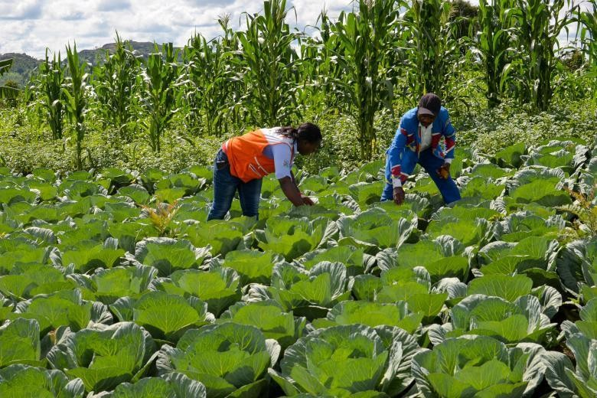

#### TASK.

As an agriculture student, write a detailed report that can be read by someone and help them overcome the problem.

(20 points)

3.

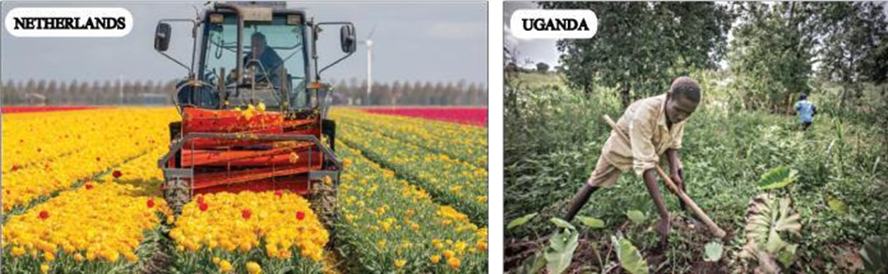

Netherlands is one of the world’s largest agricultural producing countries. It exports vegetables, fruits, flowers, meat and dairy products and as a result it earns a lot of foreign exchange, yet in Uganda, inspite of having large land for cultivation, Uganda only uses 35% of that land leading to low production, low export and low foreign exchange and low development.

TASK.

As an agriculturalist, write an essay explaining why you think the case in Uganda is like that as compared to Netherlands and what advice can you give to the government and the people in the agricultural sector on what to do in order to improve on the Agricultural sector in Uganda (20 marks)

#### END